**SQL Project ( Music_Store_Analysis)**

SQL project to analyze online music store data

This project is for beginners and will teach you how to analyze the music playlist database. You can examine the dataset with SQL and help the store understand its business growth by answering simple questions.

**Database and Tools**

My SQL

**Music Database Schema**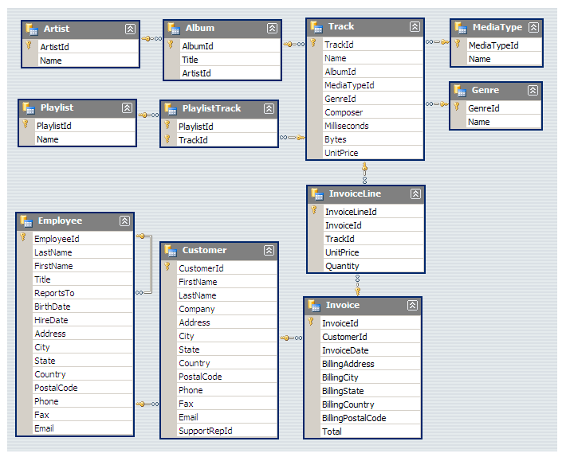

**Question Set 1 – Easy**

1. Who is the senior most employee based on job title?

2. Which countries have the most Invoices?

3. What are top 3 values of total invoice?

4. Which city has the best customers? We would like to throw a promotional Music Festival in the city we made the most money. Write a query that returns one city that has the highest sum of invoice totals. Return both the city name & sum of all invoice totals

5. Who is the best customer? The customer who has spent the most money will be declared the best customer. Write a query that returns the person who has spent the most money

**Question Set 2 – Moderate**

1. Write query to return the email, first name, last name, & Genre of all Rock Music listeners. Return your list ordered alphabetically by email starting with A

2. Let's invite the artists who have written the most rock music in our dataset. Write a query that returns the Artist name and total track count of the top 10 rock bands

3. Return all the track names that have a song length longer than the average song length. Return the Name and Milliseconds for each track. Order by the song length with the longest songs listed first

**Question Set 3 – Advance**

1. Find how much amount spent by each customer on artists? Write a query to return customer name, artist name and total spent

2. We want to find out the most popular music Genre for each country. We determine the most popular genre as the genre with the highest amount of purchases. Write a query that returns each country along with the top Genre. For countries where the maximum number of purchases is shared return all Genres

3. Write a query that determines the customer that has spent the most on music for each country. Write a query that returns the country along with the top customer and how much they spent. For countries where the top amount spent is shared, provide all customers who spent this amount Complete Project explained on YouTube Channel- click here

1. Who is the senior most employee based on job title?

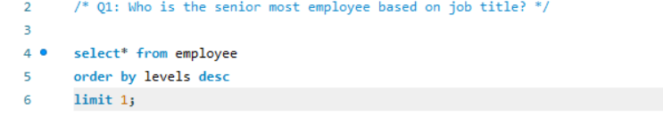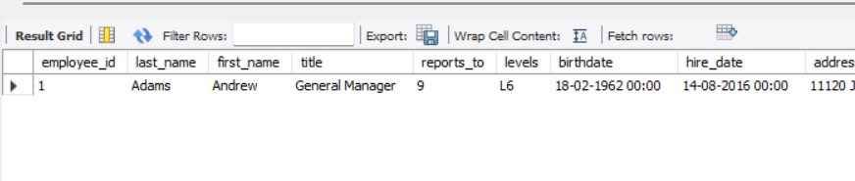

2. Which countries have the most Invoices?

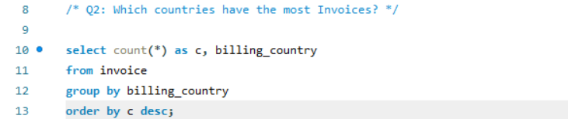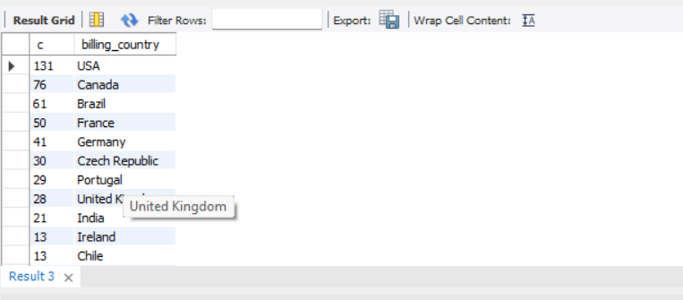

3. What are top 3 values of total invoice?

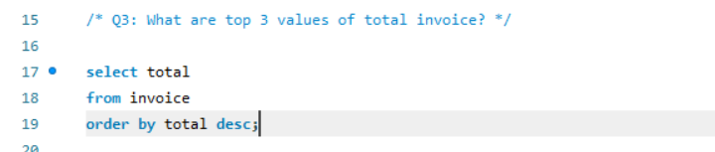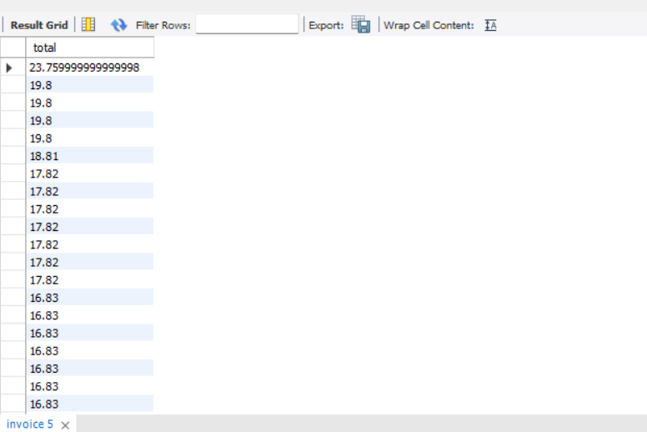

4. Which city has the best customers? We would like to throw a promotional Music Festival in the city we made the most money. Write a query that returns one city that has the highest sum of invoice totals. Return both the city name & sum of all invoice totals

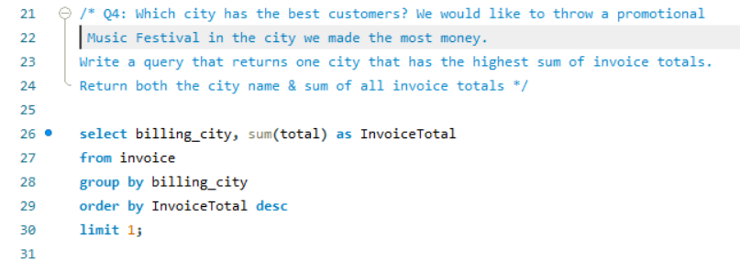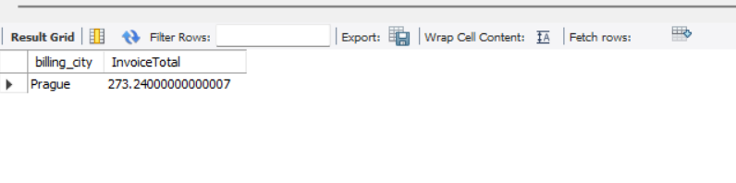

5. Who is the best customer? The customer who has spent the most money will be declared the best customer. Write a query that returns the person who has spent the most money

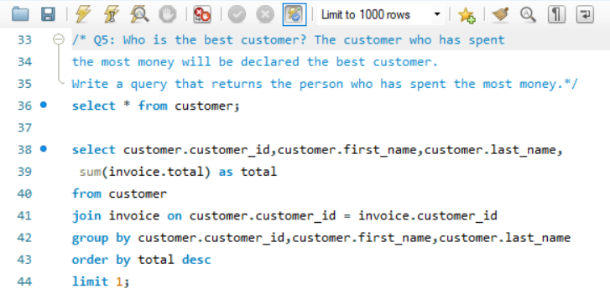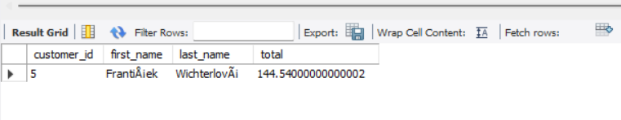

1. Write query to return the email, first name, last name, & Genre of all Rock Music listeners. Return your list ordered alphabetically by email starting with A

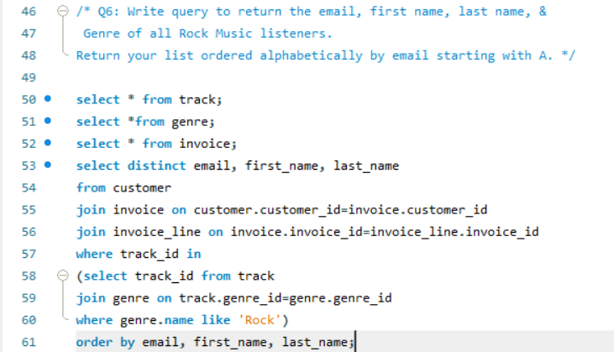

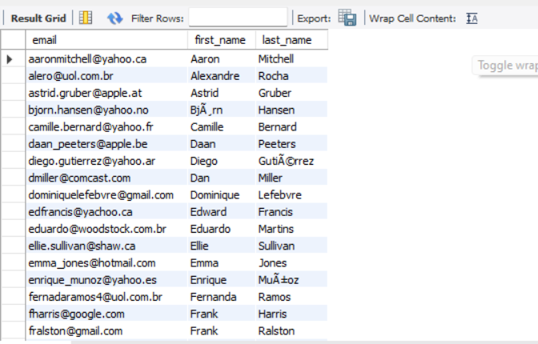

2. Let's invite the artists who have written the most rock music in our dataset. Write a query that returns the Artist name and total track count of the top 10 rock bands

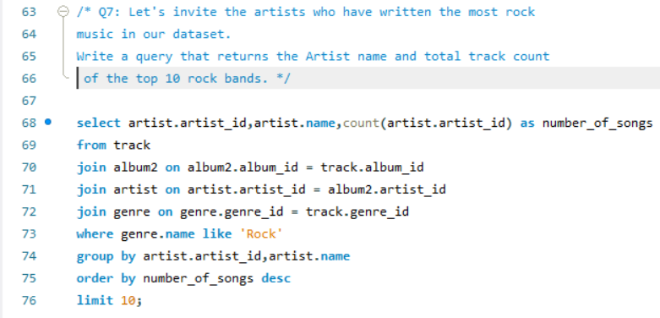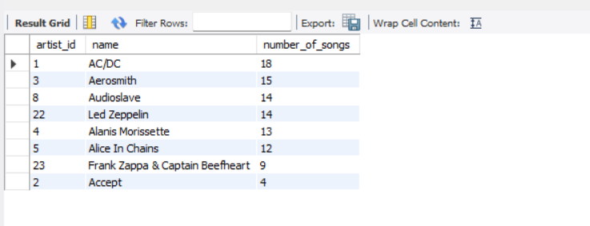

3. Return all the track names that have a song length longer than the average song length. Return the Name and Milliseconds for each track. Order by the song length with the longest songs listed first

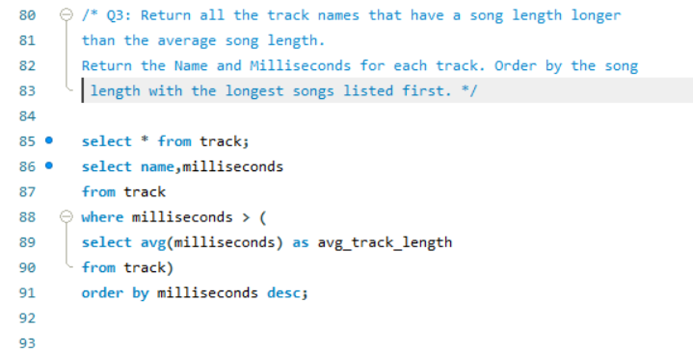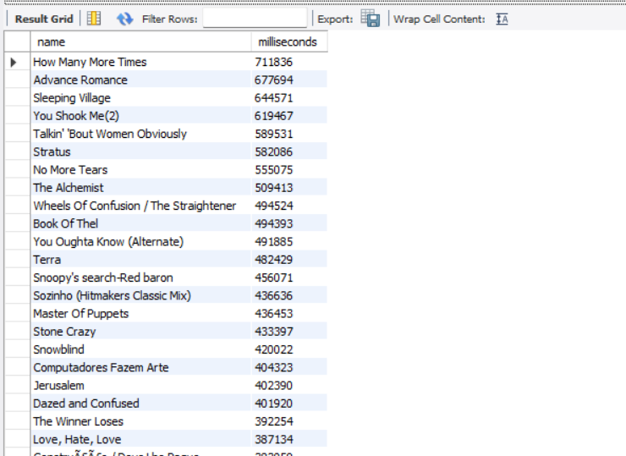

1. Find how much amount spent by each customer on artists? Write a query to return customer name, artist name and total spent

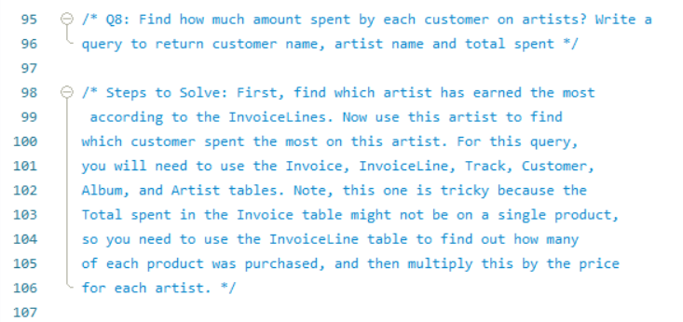 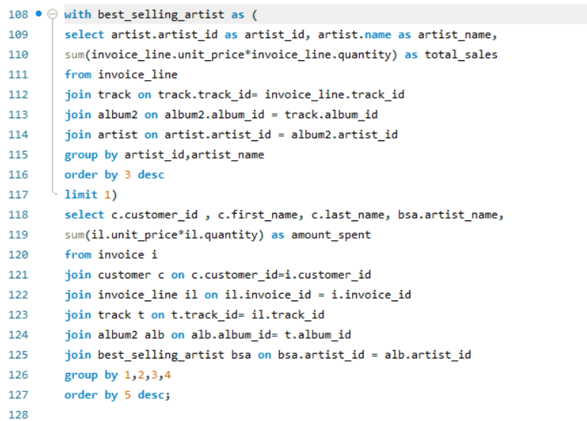

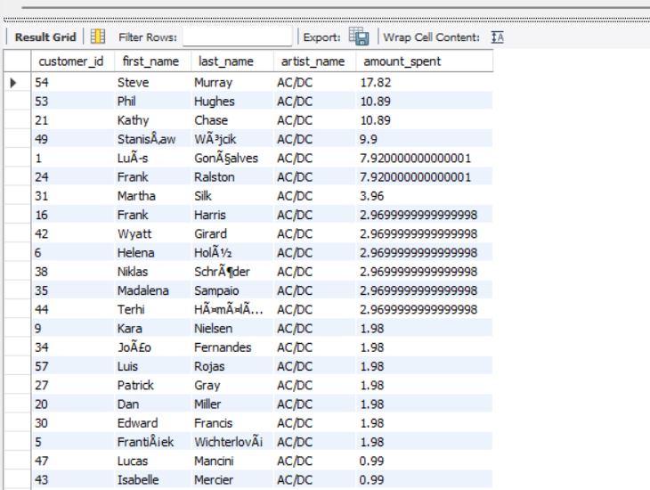

CTE stands for Common Table Expression. It is a temporary result set that can be referred to within a SELECT, INSERT, UPDATE, or DELETE statement. CTEs are defined using the WITH keyword and are often used to simplify complex queries, make code more readable, and avoid redundancy.

2. We want to find out the most popular music Genre for each country. We determine the most popular genre as the genre with the highest amount of purchases. Write a query that returns each country along with the top Genre. For countries where the maximum number of purchases is shared return all Genres

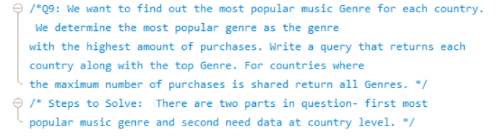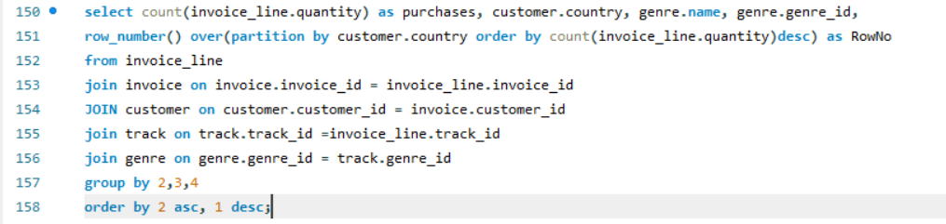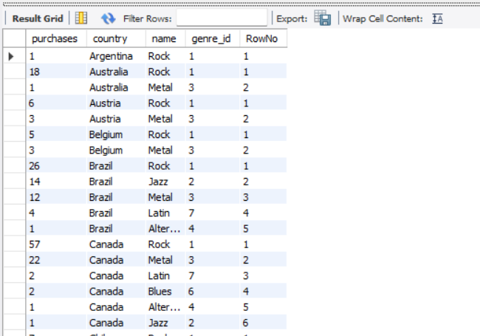

the **ROW_NUMBER()** function is often used in conjunction with the **OVER** clause and **PARTITION BY** clause to assign a unique sequential integer to each row within a partition of the result set. This is particularly useful in scenarios where you want to rank or number rows based on a specific order within a subset of the data.

Here's a breakdown of the components:

1. **ROW_NUMBER():** This is a window function in SQL that assigns a unique number to each row within a result set. The numbering starts from 1 and increases sequentially.
2. **OVER():** The **OVER** clause is used to define a window or a subset of rows for the window function to operate on. It specifies the partitioning and ordering of the result set.
3. **PARTITION BY:** The **PARTITION BY** clause divides the result set into partitions to which the **ROW_NUMBER()** function is applied separately. It essentially defines the groups or subsets within which the row numbers are generated.

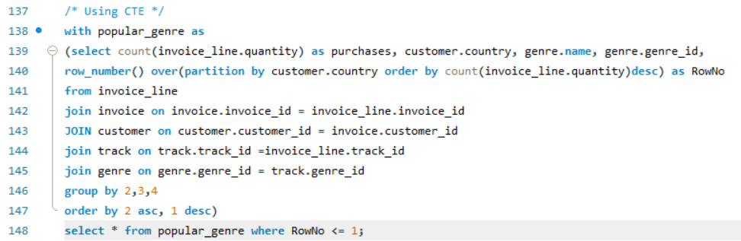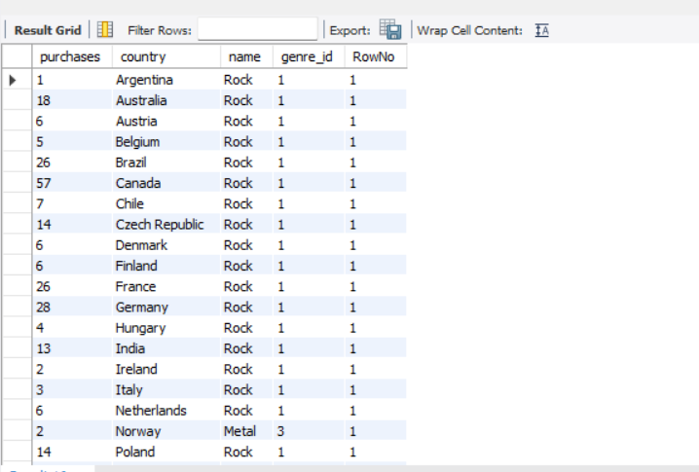

3.Write a query that determines the customer that has spent the most on music for each country. Write a query that returns the country along with the top customer and how much they spent. For countries where the top amount spent is shared, provide all customers who spent this amount .

